TASK 1

Data Analytics Process

**Task Description :-**

Without even realizing it, we utilize data analytics in our daily lives. Our job is to provide an example or examples of such a real-world scenario in which data analytics is applied and to connect it to the data analytics procedure.



**Scenario Description: -**

Let’s take a scenario of buying a smart phone from ecommerce website or market as a data analytics process. For the purpose of selecting the most suitable mobile phone to buy, so for that the person will go through the step-by-step analysis.

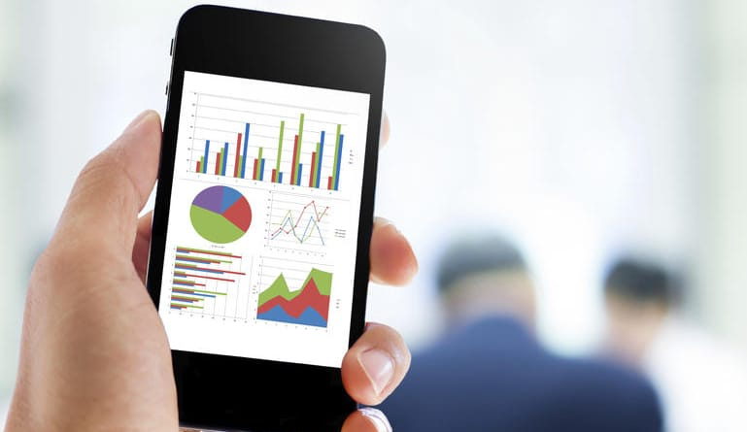

When picking the appropriate choice, the individual would do the following actions: -

**Step 1(Plan): -**

The person has decided to buy smartphone by following the current trends, based on different criteria’s budget, features (camera quality, battery life, screen size, etc.), preferred brand, and any specific needs.

**Step 2(Prepare): -**

Next that person need to check his budget how much he/she can spend, also specifications needed based on the individuals. So, for that he/she can check mobile phone models, prices, specifications, and customer reviews from e-commerce websites. Gather data on the latest mobile phone models, technical specifications, and pricing from official manufacturer websites.

Monitor social media platforms for user opinions, complaints, and experiences with specific mobile phone models.

Collect data on their own preferences, such as preferred brand, operating system (iOS or Android), desired features (camera quality, battery life, screen size, etc.), and budget constraints.

**Step 3(Process): -**

Following the collection of data from various sources, the individual can draft a list of specifications for the smartphone that best fits their needs, including the amount of RAM and internal memory, the name and type of processor, the operating system, and the quality of the camera.

**Step 4(Analyze): -**

The customer can now identify the important metrics that will help them make a purchase by using various visualization techniques. Additionally, they can make various charts and graphs to clearly compare the costs of various models and spot any discounts, as well as examine user reviews and ratings to comprehend both the positive and negative aspects of each phone from the perspective of real users.

**Step 5 (Share): -**

Following a thorough analysis, they can discuss the outcomes with friends or the retailer, who can then use them to help him to make a decision.

**Step 6(Act): -**

By using the insights gained from the analysis and also by getting the opinions from the others, customer will be able to select the right smartphone for him.